**Selenium Project: connect2tech.in-Selenium-Automation-Java-1.x**



### Use Case @ Frames

Visit the home page <http://localhost:8888/connect2tech.in-Selenium-Automation-Java-1.x/> and click on **Frames**, to launch the below screen.

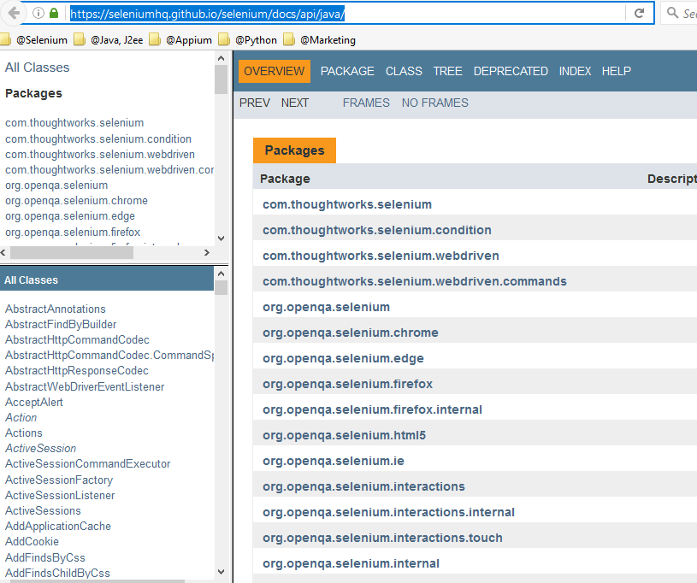

* Find out the number of **Packages** available in the above screen.
* Locate the package e.g. **org.openqa.selenium** on **top left** frame and click on the package.
* Find out the number of Interfaces, classes, Exceptions on this package from **bottom left**
* Click on WebDriver interface.
* Find out all the Implementing Classes in the WebDriver interface.
* Find out All Methods in the WebDriver interface

**Note**: Build a generic solution. It should work for all the packages.

### Use Case @ Images

Visit the home page <http://localhost:8888/connect2tech.in-Selenium-Automation-Java-1.x/> and click on **Images**, to launch the below screen.

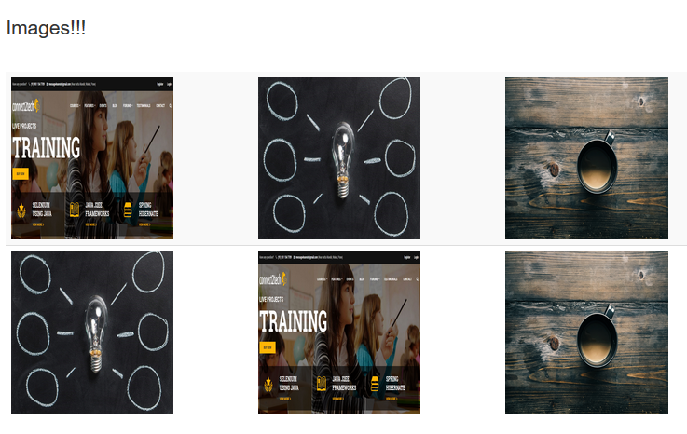

* Assert the attributes of the img i.e. width and height.
* Download all the unique images from above screen (Compare screen names for uniqueness).
* Save all the images on local drive.
* Save the image details in excel sheet (Location of image, width and height, name of images, format of images).

### Use Case @ Downloading Hyperlinks

Visit the home page <http://localhost:8888/connect2tech.in-Selenium-Automation-Java-1.x/> and click on **Hyperlinks**, to launch the below **Screen1**.

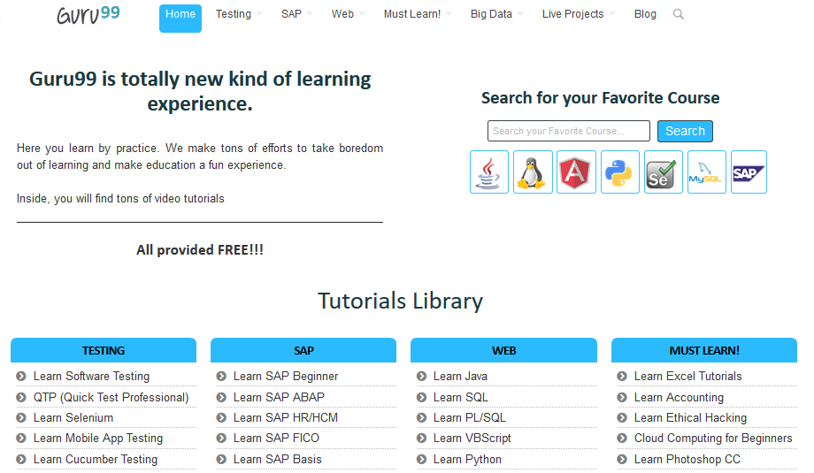

**Screen1**

Click on Home>Selenium as show in below **Screen2**.

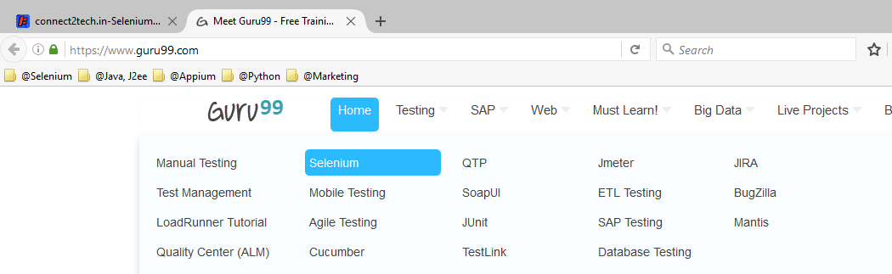

**Screen2**

The following **Screen3** will be loaded

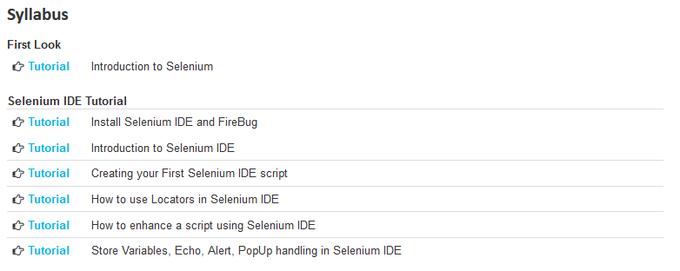

**Screen3**

* Open each Tutorial link in above page in new tab.
* Save each page on tab on local machine (make sure that for each save, there is a prompt asking location to save the page).